

**CHEMISTRY**

**UNIT 1**

**2017**

**MARKING GUIDE**

**Section One: Multiple-choice (40 marks)**

|  |  |  |  |  |  |  |  |  |
| --- | --- | --- | --- | --- | --- | --- | --- | --- |
| 1 | a □ b □ c ■ d □ |  | 6 | a □ b □ c ■ d □ |  | 11 | a □ b □ c■ d□ |  |
| 2 | a ■ b □ c □ d □ |  | 7 | a ■ b □ c □ d □ |  | 12 | a □ b□ c □ d ■ |  |
| 3 | a ■ b □ c □ d □ |  | 8 | a □ b □ c ■ d □ |  | 13 | a □ b □ c ■ d □ |  |
| 4 | a □ b ■ c □ d □ |  | 9 | a □ b ■ c □ d □ |  | 14 | a □ b □ c ■ d □ |  |
| 5 | a □ b □ c ■ d □ |  | 10 | a □ b □ c □ d ■ |  | 15 | a □ b □ c■ d □ |  |

|  |  |  |  |  |  |
| --- | --- | --- | --- | --- | --- |
| 16 | a □ b □ c□ d ■ |  |  |  |  |
| 17 | a □ b □ c □ d ■ |  |  |  |  |
| 18 | a □ b □ c ■ d □ |  |  |  | (2 marks per question) |
| 19 | a □ b ■ c □ d□ |  |  |  |  |
| 20 | a □ b □ c □ d ■ |  |  |  |  |

**Section Two: Short answer 35% (55 marks)**

This section has **eleven (11)** questions. Answer **all** questions. Write your answers in the spaces provided.

When calculating numerical answers, show your working or reasoning clearly. Express numerical answers to the appropriate number of significant figures and include appropriate units where applicable.

Spare pages are included at the end of this booklet. They can be used for planning your responses and/or as additional space if required to continue an answer.

* Planning: If you use the spare pages for planning, indicate this clearly at the top of the page.
* Continuing an answer: If you need to use the space to continue an answer, indicate in the original answer space where the answer is continued, i.e. give the page number. Fill in the number of the question(s) that you are continuing to answer at the top of the page.

Suggested working time: 60 minutes.

1. **(8 marks)**

Complete the following by giving the name or formula for the following:



|  |  |
| --- | --- |
| **Formula** | **Name** |
| CuNO3 | ***Copper (I) Nitrate*** |
| CCℓ4 | ***Carbon tetrachloride*** |
| Mg3(PO4)2 | ***Magnesium phosphate or tetrachloromethane*** |
| ***Aℓ2(CO3)3*** | Aluminium carbonate |
| ***N2O3*** | Dinitrogen trioxide |
| ***CaSO3*** | Calcium Sulfite |
| ***Fe2(HPO4)3*** | Iron (III) hydrogenphosphate |
| ***NH4+*** | Ammonium ion |

**[1 mark each correct answer]**

1. **(4 marks)**

Observe the table below:



|  |  |  |  |
| --- | --- | --- | --- |
| **Species** | **Protons** | **Neutrons** | **Electrons** |
| A | 6 | 6 | 6 |
| B | 6 | 8 | 6 |
| C | 6 | 7 | 10 |
| D | 11 | 12 | 10 |
| E | 12 | 12 | 10 |
| F | 8 | 8 | 10 |

Using the table above by writing correct letters into the appropriate boxes below.

|  |  |  |  |  |
| --- | --- | --- | --- | --- |
| **Isotopes** | ***A, B & C*** |  | **Neutral atoms** | ***A & B*** |
| **Anions** | ***C & F*** |  | **Cations** | ***D & E*** |

**[1 mark for correct for ALL correct letters in a box]**

1. **(3 marks)**

Complete the table by drawing or naming the following hydrocarbons using IUPAC nomenclature.



|  |  |
| --- | --- |
| **Structure** | **IUPAC Name** |
| Cℓ H Cℓ  | | |  H – C – C – C – H  | | |  H H H | ***1,3 - dichloro-propane***  **Correct Name (1)** |
|  | 1-bromo-2-methylbenzene  **Structure (1)** |
| Br                    |             CH = C – CH2   |               |        Br             CH3 | ***1-2-dibromo-but-1-ene***  **Correct name (1)** |

1. **(4 marks)**

Consider the following reactions and complete the tables that follow.

* 1. Excess bromine gas reacts with ethene gas. (4 marks)

|  |  |
| --- | --- |
| **Observation** | ***Red brown gas fades (is decolourised* (1)** |
| **Balanced chemical equation with structural formula**  **(show all atoms)** | **H H Br Br**  **| | | |**  **H - C = C - H + Br2 🡪 H - C – C – H**  **| |**  **H H**  **Structural formula (1)**  **Correct balanced equation (1)** |
| **Name of organic product** | ***1,2 – dibromoethane* (1)** |

1. **(4 marks)**

On the axes below, sketch an energy profile diagram for the following reaction. Clearly label the reactants, products, axes, and ∆H. Includes all values.

H2 (g) + Cℓ2 (g) 🡪 2HCℓ (g) ∆H = – 185 kJ mol-1

**Enthalpy**

H2 (g) + Cℓ2 (g)

**Both Axes (1)**

∆H = - 185 kJ mol-1

**∆H (1)**

**Products/Reactants (1)**

**Exothermic (1)**

HCℓ (g)

**Time**

1. **(9 marks)**

Write balanced **FULL** equations for the following reactions described below. Include the states f matter for all the species. For example, solid copper (II) sulfate as CuSO4 (s).

States of matter for of all species (1 mark)

**Correct equation (1) Each question**

**Balanced correctly (1) Each question**

**States of matter for entire question (1) only**

* 1. Silver nitrate solution is mixed with iron (II) chloride solution to produce solid silver chloride and iron (II) nitrate solution. (2 marks)

***2AgNO3 (aq) + FeCℓ2 (aq) 🡪 2AgCℓ (s) + Fe(NO3)2 (aq)***

* 1. Solid Aluminium carbonate and a solution of nitric acid react to form a solution of aluminium nitrate, carbon dioxide and water. (2 marks)

***Al2(CO3)3 (s) + 6 HNO3(aq) 🡪 2 Al(NO3)3 (aq) + 3H2O (ℓ) + 3CO2 (g)***

* 1. Carbon dioxide gas is bubbled into limewater (Ca(OH)2) to produce calcium carbonate precipitate and a second product.

(2 marks)

***CO2 (g) + Ca(OH)2 (aq) 🡪 CaCO3 (s) + H2O (ℓ)***

(d) A dilute solution of ethanoic acid reacts with a solution of magnesium hydroxide to form a solution of magnesium ethanoate and water.

**2CH3COOH(aq) + Mg(OH)2 (aq)** ***🡪 Mg(CH3COO)2 (aq) + 2 H2O (l)***

1. **(6 marks)**

Beryllium, Magnesium and Calcium are metals in group 2 of the periodic table. Answer the following questions with explanation using the atomic structure of these elements.

* 1. Explain why these metals are malleable. (2 marks)
* ***3D lattice form strong electrostatic force between delocalised e- and positive ions.*  (1)**
* ***When the lattice is rolled over into new positions, this force prevents repulsive forces (separation) making them malleable.* (1)**
  1. Describe and explain the trend in first ionisation energy for Beryllium, Magnesium and Calcium. (4 marks)
* ***1st IE decreases down the group. i.e. Be = highest, Ca = lowest.*  (1)**
* ***As you move down the group, the number of e- shells increases*. (1)**
* ***The valence e-are further from the nucleus and i.e. less electrostatic attraction to* the nucleus. (1)**
* This requires less energy to be remove outermost e-. (1)

1. **(4 marks)**

Carbon dioxide is a colourless gas which occupies 0.04% of our atmosphere. The melting point and the boiling point of carbon dioxide are – 56.6 oC and – 78.5 oC respectively.

Explain why carbon dioxide has a very low melting and boiling point.

* ***Carbon dioxide is a covalent molecule.*  (1)**
* ***Force between CO2 is a weak intermolecular force (dispersion force)* (1)**
* ***Less heat energy to overcome this force, i.e. low MP/BP* (1)**
* ***Therefore, the MP/BP are low.* (1)**

1. **(8 marks)**

Complete the following table.

|  |  |  |  |  |
| --- | --- | --- | --- | --- |
| **Species** | **Bonding present**  **(Covalent moleculer, covalent network, ionic and/or metallic)** | **State at room temperature**  **(aq, s, ℓ or g)** | **Electrical conductivity at room temperature**  **(Yes or no)** | **Gold as metal (1)**  **Diamond and SiO2 as covalent network (1)**  **NO2 as covalent molecule (1)**  **Marble and AgNO3 as BOTH ionic and covalent (2)**  **States all correct (1)**  **Conductivity all correct (2)** |
| Gold | ***Metallic*** | ***s*** | ***Yes*** |
| Diamond | ***Covalent network*** | ***s*** | ***No*** |
| SiO2 | ***Covalent network*** | ***s*** | ***No*** |
| NO2 | ***Covalent molecule*** | ***g*** | ***No*** |
| Marble (CaCO3) | ***Ionic and Covalent*** | ***s*** | ***No*** |
| AgNO3 Solution | ***Ionic and Covalent*** | ***aq*** | ***Yes*** |

**Question 35 (7 marks)**

The average human requires 120 grams of glucose (C6H12O6) per day.

* 1. Calculate the percentage by mass of carbon in each glucose molecule. (3 marks)

**(1)**



**(1)**



**(1)**



* 1. How many grams of CO2 (in the photosynthesis reaction) are required for this amount of glucose? The photosynthetic reaction is:

6CO2 + 6H2O 🡪 C6H12O6 + 6O2

(4 marks)

**(1)**



**(1)**



**(1)**



**(1)**



**End of Section Two**

**Section Three: Extended answer 40% (80 marks)**

This section contains **five (5)** questions. You must answer **all** questions. Write your answers in the spaces provided below.

Where questions require an explanation and/or description, marks are awarded for the relevant chemical content and also for coherence and clarity of expression. Lists or dot points are unlikely to gain full marks.

Final answers to calculations should be expressed to the appropriate number of significant figures.

Spare pages are included at the end of this booklet. They can be used for planning your responses and/or as additional space if required to continue an answer.

* Planning: If you use the spare pages for planning, indicate this clearly at the top of the page.
* Continuing an answer: If you need to use the space to continue an answer, indicate in the original answer space where the answer is continued, i.e. give the page number. Fill in the number of the question(s) that you are continuing to answer at the top of the page.

Suggested working time: 70 minutes.

**Question 36 (13 marks)**

The following simplified diagram shows the path of a 20Ne+ ion through a mass spectrometer.

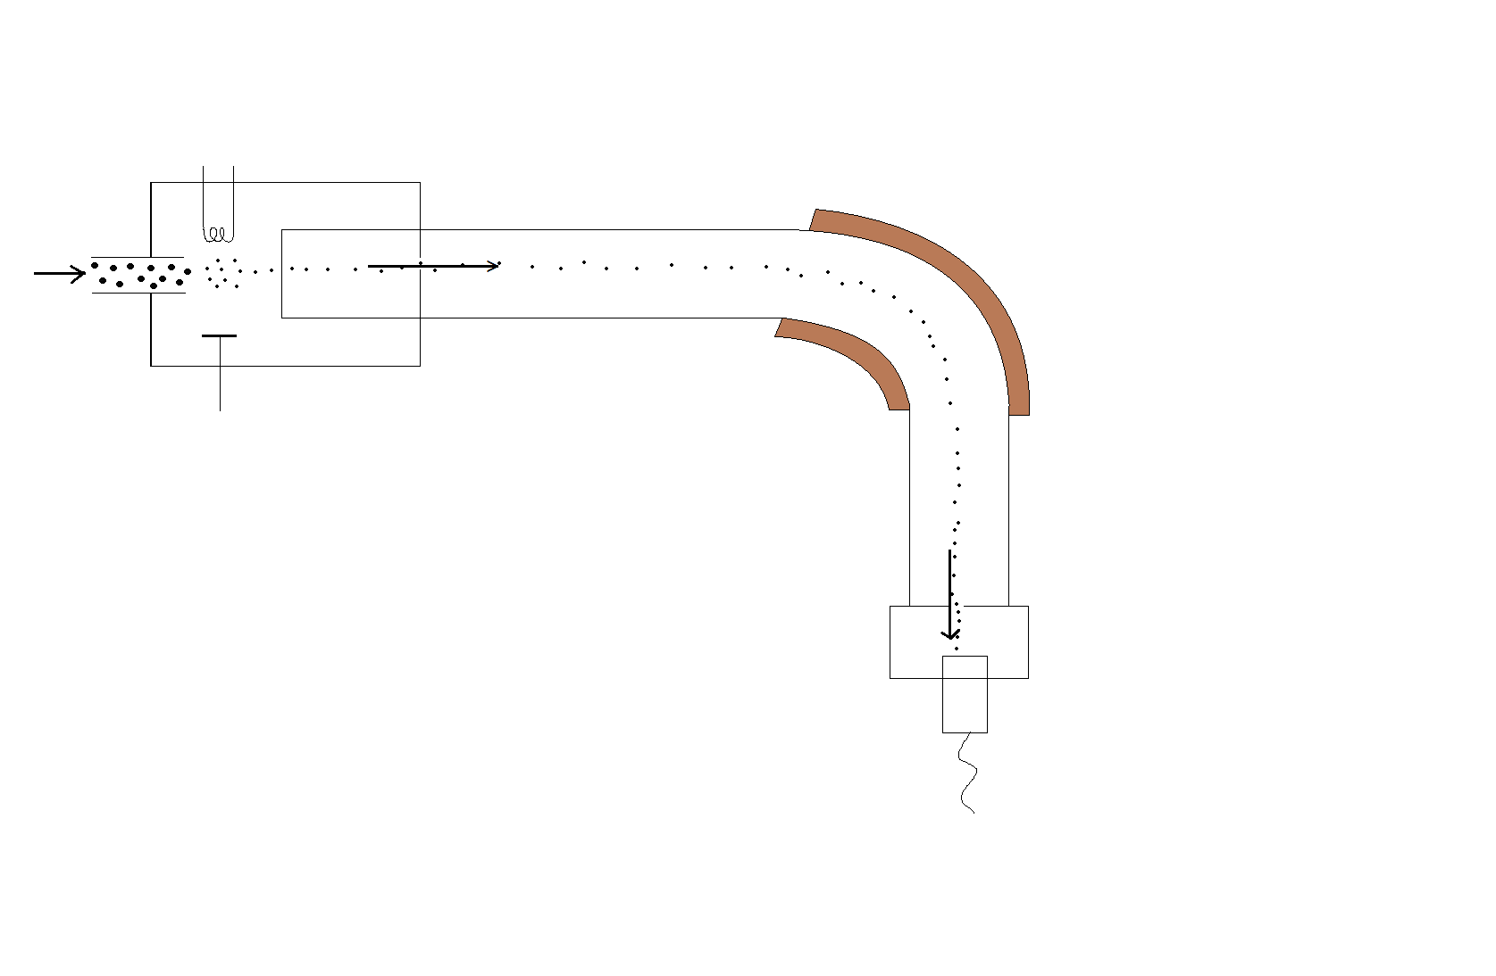

A

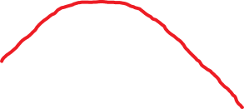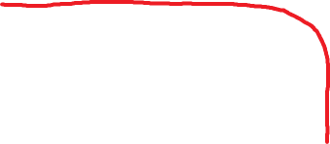

* + 1. What is the name of part A in this mass spectrometer? (1 mark)

***Magnet (or magnetic field)* (1)**

* + 1. Why is part A required in this mass spectrometer? (1 mark)

***When ions are passing the magnet or magnetic field, they change their direction.* (1)**

**Continue Question 36**

* + 1. On the diagram of the mass spectrometer, sketch the path that would be taken by a 21Ne+ ion introduced if it were into the spectrometer at the same time as the 20Ne+ ion shown. (1 mark)

**The curve should deviate less (i.e. greater curve around area A) (1)**

* + 1. Explain why the paths travelled by the two ions differ. (2 marks)
* ***Ne-21 ion is a heaver particle due to the increase of mass number*  (1)**
* ***As such it is bent (deflected) less than Ne-20 ion* (1)**

The relative abundances of all the neon isotopes in a sample is collected using the mass spectrometer. The result is shown below. Note that m/z value is equivalent to the mass number of a neon ion. (For example, m/z = 20 means 20Ne+ isotope.)

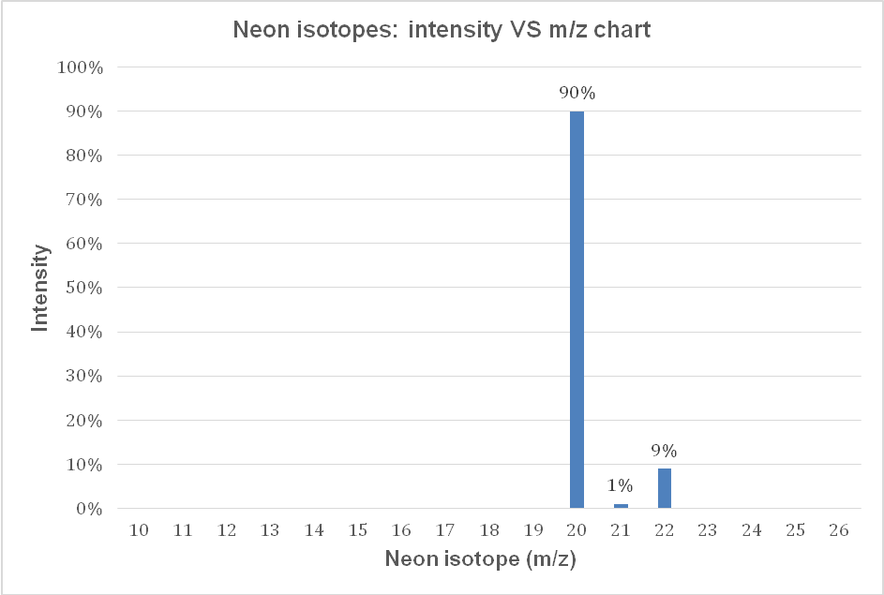

* 1. Use the above graph to calculate the relative atomic mass of neon. (2 marks)

**(1)**



**= 20.19**

**= 20.2 (1)**



Atomic absorption spectroscopy (AAS) can be used to distinguish different elements such as neon and helium atoms. The diagram below shows the emission spectra of helium and neon.

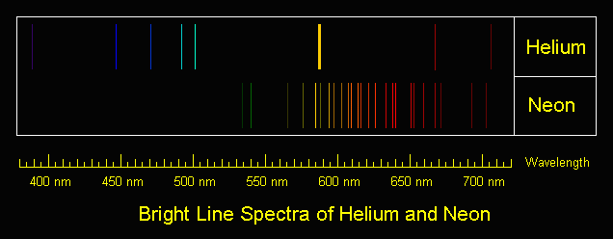

* 1. Explain how these spectra lines are produced. (3 marks)

* ***e- are excited and jump to higher energy levels using by absorbing energy.* (1)**
* ***When e- are coming to lower energy levels, coloured light is emitted.* (1)**
* ***Different jumps between energy levels will produce different colours.*  (1)**
  1. The number of lines spectra of helium and neon are different. Give an explanation for this.

(3 marks)

* ***Helium (2 e-) and neon (10 e-) have different numbers of e- and different numbers of energy levels.* (2)**
* ***The jumps between the energy levels of both elements are unique.*  (1)**

**Question 37 (15 marks)**

The following table shows the radii of different elements.

|  |  |  |
| --- | --- | --- |
| **Element** | **Atomic Number (Z)** | **Atomic radius**  **( x10-12  metres)** |
| O | 8 | 66 |
| F | 9 | 68 |
| Ne | 10 | 67 |
| Na | 11 | 186 |
| Mg | 12 | 160 |
| Al | 13 | 143 |
| Si | 14 | 118 |
| P | 15 | 110 |
| S | 16 | 102 |
| Cl | 17 | 99 |
| Ar | 18 | 95 |

* 1. Graph these results below, by plotting the atomic number on the horizontal axis. If you make a mistake, a spare grid is available at the back of this booklet. (4 marks)

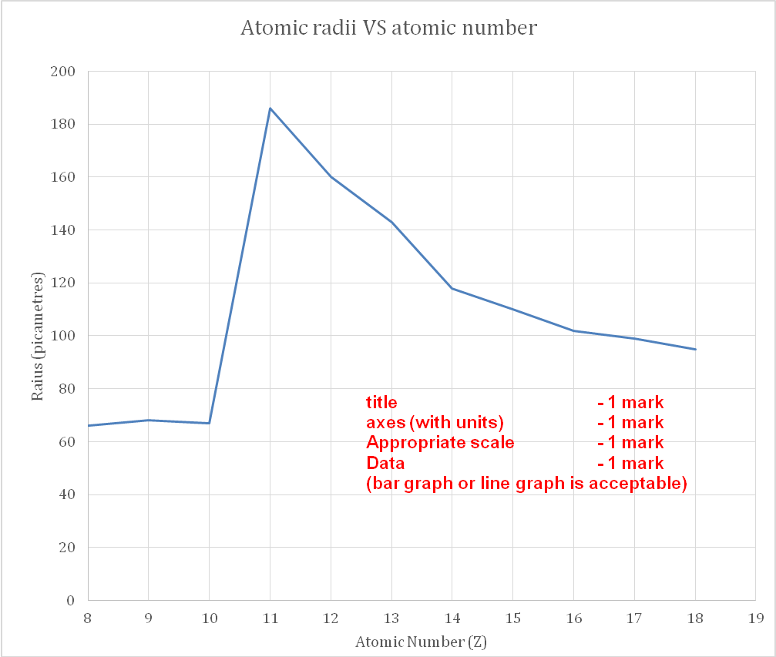

(b)

* + 1. From the graph, describe the trend in the atomic radius that occurs from sodium to argon. (1 mark)
* ***The size of the radius decreases.* (1)**
  + 1. Explain why this trend occurs. (3 marks)
* ***The number of protons increases.* (1)**
* ***Successive e- are placed in the same shell.*  (1)**
* ***As such, greater attraction occurs between e- and nucleus.* (1)**

(c) Compare the radii of an oxygen atom and sulfur atom. Explain the difference.

(2 marks)

* ***Oxygen has 2 e- shells and sulfur has 3 shells.*  (1)**
* ***i.e. S’s valence e- are further away from nucleus.*  (1)**

(d) Would a chloride ion be bigger or smaller than the chlorine atom? Explain your answer.

(3 marks)

* ***Chloride ion is bigger.*  (1)**
* ***Chloride ion has a greater number of e- than protons as it gained 1 e-* (1)**
* ***This unbalance of charge causes less electrostatic attraction.* (1)**

(e) Describe the changes in electronegativity that would be observed from sodium to Argon. (2 marks)

* **Electronegativity increases from sodium to argon (1)**
* **Because nuclear charge increses (1)**

**Question 38 (16 marks)**

When magnesium metal reacts with oxygen from the air, a grey-white solid is formed. This chemical reaction can be performed in a crucible in the science lab.

(a)Write a balanced chemical equation for this reaction. (2 marks)

***2 Mg+ O2 🡪 2 MgO*  Correct reactants/products (1) correct coefficients (1)**

The setup of the combustion reaction is shown below:

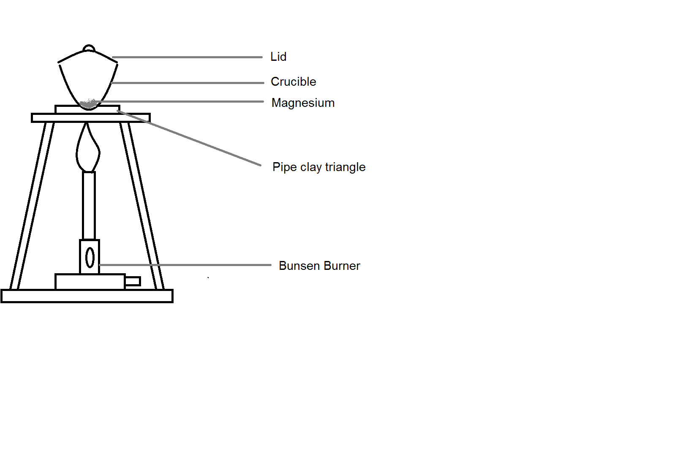

A student, Paul, wants to use this experiment to find the mass of oxygen reacting with the magnesium.

(b)The teacher of the student, Mrs Philips, suggests that the lid of the crucible need to be open slightly during the combustion. Explain the reason for this. (1 mark)

* ***To encourage more O2 in the atmosphere to undergo combustion*  (1)**

**(or equivalent)**

After the experiment, Paul summarises his result as follows:

Mass of crucible and lid (g) 38.5980 g

Mass of crucible, lid and magnesium (g) 38.7860 g

Mass of crucible, lid and magnesium oxide (g) 38.8873 g

(c) Use Paul’s results to calculate:

(2 marks)

|  |  |
| --- | --- |
| **Mass of Magnesium (g)** | **0.188** |
| **Mass of Magnesium oxide (g)** | **0.289 (0.2893)** |

(d)Calculate the number of moles of magnesium at the beginning of the experiment. (2 marks)

**(1)**  
 **(1)**



(e)Calculate the number of moles of magnesium oxide produced at the conclusion of the experiment. (2 marks)

**(1)**  
 **(1)**



(f)Using your equation and answer from part (d), calculate the number of moles of magnesium oxide Paul is **expected** to produce in this experiment. Explain why the expected value is different to part (e). (3 marks)

* ***Expected: 7.73x10-3 mol of MgO*  (1)**
* ***Molar ratio of Mg : MgO is 1:1*  (1)**
* ***Not all Mg may undergo chemical reaction (or equivalent)*  (1)**

(g)Use the answer from part (d), calculate the theoretical mass of the oxygen gas reacted in this combustion. How does this value compare to the amount which actually reacted? (4 marks)



**(1)**



**(1)**  
 **(1)**



**This value is more than the expected. (1)**

**Question 39 (21 marks)**

A fuel is any material that can be made to react with oxygen gas so that it releases energy as heat. Fossil fuels are fuels from natural processes such as anaerobic decomposition of buried dead organisms. One example of a fossil fuel is ethane.

The **unbalanced** chemical equation of the combustion of ethane is shown below:

***2*** C2H6 + ***7*** O2 🡪 ***4*** CO2 + ***6*** H2O

**(1)**

(a)Balance the chemical equation above using whole numbers.

(1 mark)

(b) Draw dot diagram (Lewis structures) for C2H6. Show all valence shell electron pairs as either : or — (2 marks)

|  |  |  |  |  |  |
| --- | --- | --- | --- | --- | --- |
| For example, water |  | or |  | or |  |

|  |  |
| --- | --- |
| C2H6 | **H H**  **| |**  **H – C – C – H**  **| |**  **H H**  **(2)** |

The following table shows how much heat energy is required to break each bond of all reactants and the total heat energy required for the reaction. This can be done by referring to the chemical equation in part (a).

|  |  |  |  |  |  |
| --- | --- | --- | --- | --- | --- |
| **Species** | **Bond within the molecule** | **Number of bond in each molecule** | **Number of molecules from the equation** | **Energy required to break one bond (kJ/mol)** | **Energy required to break all bonds (kJ/mol)** |
| C2H6 | C – C  (single bond) | 1 | 2 | 347 | 1 x 2 x 347 = 694 |
| C – H  (single bond) | 6 | 2 | 410 | 6 x 2 x 410 = 4920 |
| O2 | O = O  (double bond) | 1 | 7 | 494 | 1 x 7 x 494 = 3458 |
|  |  |  | **Total energy required to break all bonds** | | 9072 |

(c)Use the method in previous page and equation in part (a) to complete the following table.

(4 marks)

|  |  |  |  |  |  |
| --- | --- | --- | --- | --- | --- |
| **Species** | **Bond within the molecule** | **Number of bonds in each molecule** | **Number of molecules from the equation** | **Energy released when forming one bond (kJ/mol)** | **Energy released when forming all bonds (kJ/mol)** |
| CO2 | C = O  (double bond) | ***2*** | ***4*** | 799 | ***6392*** |
| H2O | H – O  Single bond) | ***2*** | ***6*** | 460 | ***5520*** |
|  |  | **[1 mark each column]** | **Total energy required to form for all bonds** | | ***11912***  **(1 mark)** |

(d) By considering the energy released when new bonds form and the energy required for breaking bonds. Calculate the net energy change. Determine if the reaction is an endothermic or exothermic reaction. (2 marks)

* **(1)**



* ***Exothermic.*  (1)**

(e)

(i) Is the value of ∆H positive or negative? Explain your answer. (2 marks)

* ***Negative.* (1)**
* ***The enthalpy of the products is less than the enthalpy of the reactants (change in enthalpy is negative).* (1)**

(ii) Describe a consequence that occurs to the surroundings after the chemical reaction.

(1 mark)

* ***Temperature of the surroundings will increase.*  (1)**

1.00 tonne of ethane is pumped into a combustion chamber to undergo this combustion reaction. Assume that there is no loss of energy in the reaction.

(f) Calculate the number of moles of ethane reacted. (2 marks)

**(1)**   
 **(1)**



**Continue Question 39**

* 1. Calculate the mass, in tonnes, of oxygen required in this reaction if the ethane is fully reacted. (4 marks)

**(1)**  
 **(1)**



**(1)**



**(1)**



* 1. Using the answers in parts (d) and (f), calculate the energy produced by combusting of 1.00 tonne of ethane. (3 marks)

**(1)**



**(1)**  
 **(1)**



**End of examination.**